Name sorting code exploration
Both these scripts are Python and JavaScript are a simple name sorting script. They both operate in the same way but use different syntaxes in their own languages. Although they both provide the same output, they use different commands to help set functions, variable and outputs.
Working through these scripts in a logical flow as the script would be ran starting from top to bottom.
Figure 1: Defining a function in Python
Figure 2: Defining a process in JavaScript
Here we have the first differences the code runs. The overall concept of both programming languages feel similar in the sense that learning one will give you the ability to pick up similarities and layout in the other (Coronel, 2025).Firstly adding comments, an essential part of coding for detailing and information, is just a simple as a different key used as seen above Python being ‘#’ and JS ‘//’. Straight forward enough and then defining function is very similar in the sense of syntax to tell the code a function is being defined, followed by the function name, and then opening the function. These of course differ In syntax Python uses ‘def’ to define the function name, but JS uses ‘function’ these both let the script know a function is being defined. Best practices come into play now. Naming conventions are different in each language. Python uses snake_casing naming convention which means defined names or variable with multiple words should be separated by an underscore compared to JS which uses camelCasing where each new word should start with a capital letter (Cundiff, 2022). Both paratheses data input are the same which take in a variable to run through the function and then both opening with a ‘:’ or ‘{‘.
Moving on into the body of the functions for each language and the modification.
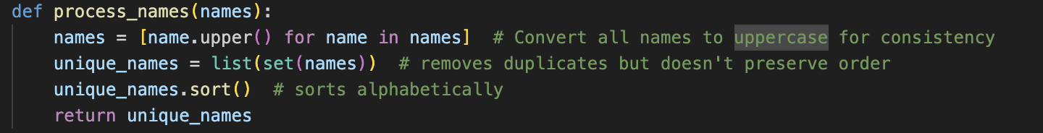
Figure 3: Python name processor function
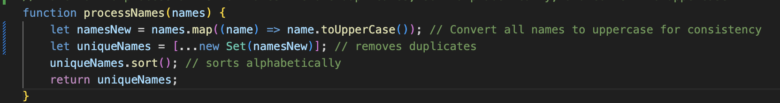
Figure 4: JavaScript name processor function
Now the modification I made to each script would be the use of converting ‘names’ variable passed into the function due to the function originally skipping through the same name if they had case sensitive differences in as below in figure 4.
Figure 4: Original output of the scripts
Figure 5: Output after modifications
As opposed to figure 5 which has filtered out the same name regardless of the casing. This modification I built bring the list passed through to a uniformed standard and then compares them so there is no duplicate data passed through. How I did this in each language was redefine the names variable as itself and alters the list as the same name. In Python I used list comprehension and a for loop to iterate through the original list and the method ‘.upper()’ to convert each iteration of the list to uppercase. Same concept in JS but I used the map method which uses the map method and the ‘=>’ and creates a new list where it adds each name converted to uppercase to the new list. Notice how each line in JS ends with; and must be closed off at the end of the function using } where python does not and this is just a small example of the simplicity of Python. Further into the function body we see a new defined where the duplicate names are removed which is almost identical in both languages for the rest of the function. These both use either ‘list’ or ‘…new’ to create new list of the unique values passed through by the previously created all capitals list. These are both done by the method ‘set’ which essentially return unique values of each list removing the duplicates.
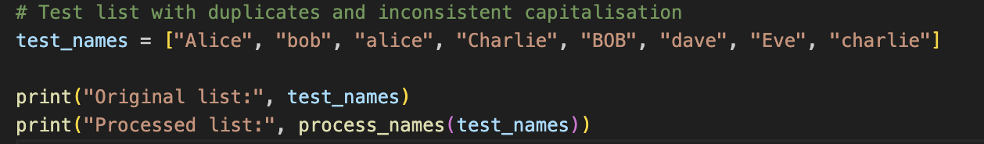
Figure 6: Calling the function in Python
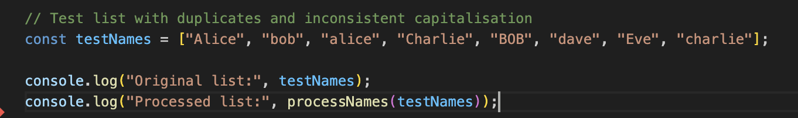
Figure 7: Calling the function in JS

The final pieces of the puzzle. This is where the data is created to test and the function are called. As seen above not syntax is needed to define a variable or list in Python its JS uses ‘const’ which means a static variable that cannot be changed or altered unlike the previous ‘let’ method. Again, the whole script follows the same functionality but with just different syntax console.log and print are both used to push outputs when running the code and the function is called by using the name and then the data you want to pass in the paraeneses.
These two scripts are very similar and both changes although provide the same output used different syntaxes. Learning the concept of programming and logical computational movement allows you to understand and predict different programming layout.

References:
Coronel, L. (2025) Python vs. JavaScript Comparaison for 2025. Available at : https://blog.teamtreehouse.com/python-vs-javascript-comparison-for-2025-2#:~:text=If%20you%20already%20know%20JavaScript,flow%20(loops%2C%20conditionals). (Accessed: 11/03/2026)
Cundiff, J. (2022) Diving into Java (with strong JavaScript and Python background) Part 1(Naming Conventions and hello World). Available at: https://jon-cundiff.medium.com/diving-into-java-with-strong-javascript-and-python-background-part-1-naming-conventions-and-d06c6aa5141e (Accessed: 11/03/2026)
Koldovskyy, V. (2025) Python vs. JavaScript: Which Programming Language To Choose in 2025? Available at: https://career.softserveinc.com/en-us/stories/python-or-javascript (Accessed: 11/03/2026)

